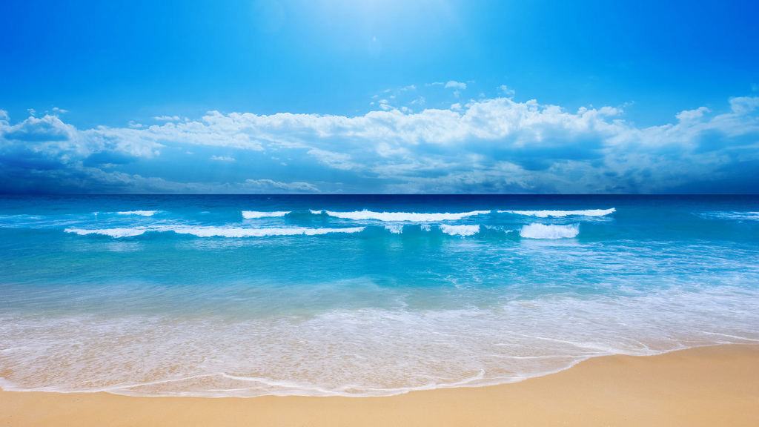
AAPA 59th ANNUAL CONVENTION
Sonesta Resort
Hilton Head Island, South Carolina
May 17-20, 2018

Thursday – May 17

12:00 p.m. - 6:00 p.m. Registration - Suite 2001

6:00 p.m. – 7:30 p.m. President’s Reception - The Pavilion

Hospitality Suite - Suite 2001

Open-After Dinner Drinks

Friday – May 18

6:30 a.m. - 9:00 a.m. Continental Breakfast

Hospitality Suite - 2001

9:00 a.m. -12:00 p.m. Business Session - Savannah Ballroom A

8:30 a.m. – 1:45 p.m. Ladies Depart- Sonesta Hotel

Daufuskie Island History & Artisans Tour

Hospitality Suite - Suite 2001

Open- Snacks & Refreshments

1:00 p.m. - Until Golf Tournament – Oyster Reef Golf Club

Saturday –May 19

6:30 a.m. - 9:00 a.m. Continental Breakfast- Suite 2001
Hospitality Suite Open
Snacks & Refreshments

6:30 p.m. – 7:00 p.m. Reception- Santee Ballroom Foyer
7:00 p.m.-until Dinner – Santee Ballroom B
Entertainment – Emerald Empire Band

Sunday – May 20

6:30 a.m. - 9:00 a.m. Continental Breakfast – Suite 2001
“All Events are Resort Casual”

