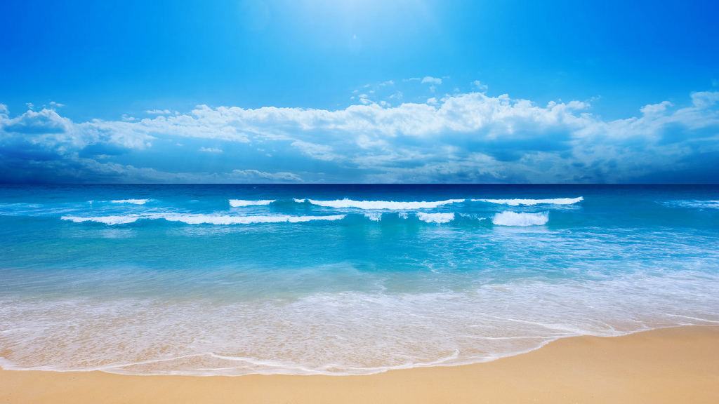
AAPA 59th ANNUAL CONVENTION
Sonesta Resort
Hilton Head Island, South Carolina
May 17-20,2018

Thursday – May 17

12:00 p.m. - 6:00 p.m. Registration –

6:00 p.m. – 7:30 p.m. President’s Reception

Hospitality Suite Open-after dinner drinks

Friday – May 18

6:30 a.m. - 9:00 a.m. Continental Breakfast –

9:00 a.m. -12:00 a.m. General Business Session –

9:00 a.m. – 12:00 a.m. Ladies Breakfast/Event –

Hospitality Suite Open- Snacks & Refreshments

1:00 p.m. - Golf Tournament – Oyster Reef Golf Club

Saturday –May 19

6:30 a.m. - 9:00 a.m. Continental Breakfast –

Hospitality Suite Open- Snacks & Refreshments

6:30 p.m. – 7:00 p.m. Reception –

7:00 p.m.-until Dinner –

Entertainment –

Sunday – May 20

6:30 a.m. - 9:00 a.m. Continental Breakfast –

All Events are Resort Casual

